🎯 Executive Summary: Gap Generatif SIDIX

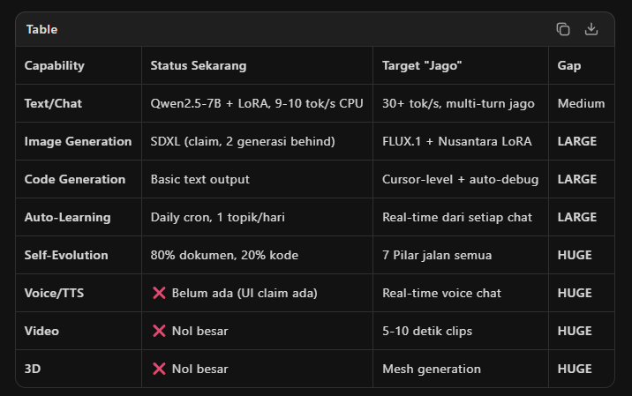Verdict: SIDIX punya fondasi visioner (IHOS + self-hosted), tapi eksekusi generatif masih level MVP. Image masih SDXL padahal FLUX sudah rilis. Code masih text-block padahal harusnya multi-file project. 7 Pilar Jiwa masih 80% dokumen, 20% kode.

🔴 5 Masalah Generatif Kritis

1. Image Gen: SDXL Sudah Ketinggalan
Fakta: SDXL rilis 2023. Sekarang 2026, FLUX.1, SD3.5, dan Ideogram sudah jauh lebih bagus. SIDIX masih claim SDXL = image generation "lokal". User akan bandingkan dengan Midjourney/Leonardo dan kecewa.
Fix: Upgrade ke FLUX.1-schnell (4-step, bisa jalan di 16GB VRAM, atau 8-bit quantized di 8GB). Ini gratis, open-source, dan kualitasnya midjourney-level.

2. Code Gen: Belum Sampai Cursor-Level
Fakta: SIDIX generate code dalam text block. Cursor generate multi-file project dengan debugging otomatis. Developer akan nggak puas cuma dapat function snippet.
Fix: Tambah code_validator.py (syntax check auto) + project_scaffold.py (generate struktur folder/file lengkap) + debug loop (generate→run→catch error→fix→retry, max 3x).

3. 7 Pilar Jiwa: Arsitektur Brilliant, Implementasi 20%
Fakta: Nafs/Aql/Hikmah punya kode partial. Qalb/Ruh/Hayat/Ilm masih konsep di dokumen. Jiwa Orchestrator belum jadi entry point utama.
Fix: Wire Nafs dulu (ganti agent_react.py → JiwaOrchestrator). Baru satu per satu activate pilar lainnya. Jangan semua sekaligus.

4. UI Claim vs Backend Reality
Fakta: UI claim "Creative — Image, video, TTS & UI". Tapi backend: image = SDXL (outdated), video = nggak ada, TTS = nggak ada. Ini disconnect yang berbahaya — user click "Creative" expecting video, dapat error.
Fix: Nggak usah claim video/TTS di UI kalau backend belum siap. Atau tambah "Coming Soon" badge. Jangan bikin user frustrasi.

5. Auto-Learning: Batch, Bukan Streaming
Fakta: Jariyah v2 jalan sekali sehari via cron. AI yang "hidup" harus belajar dari setiap interaksi, nggak cuma sekali sehari.
Fix: Jariyah v3 — real-time capture dari setiap chat, user feedback 👍/👎 langsung masuk training pipeline, drift detection otomatis trigger retrain.

🚀 ROADMAP: 4 PHASE MENUJU AI GENERATIVE JAGO
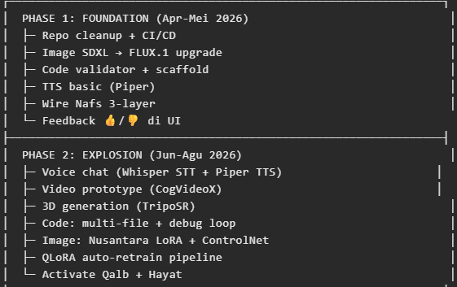
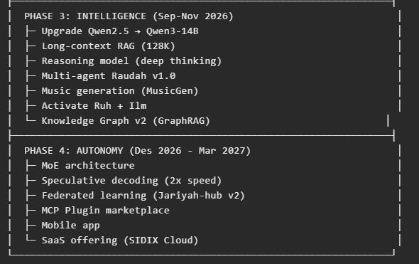

💰 Hardware Roadmap (Budget-Realistis)
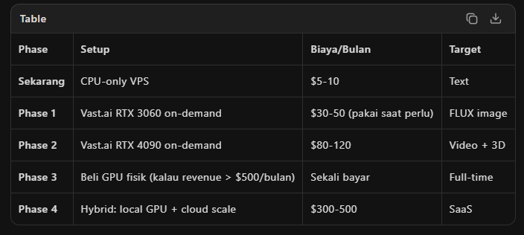
Tips: Jangan beli GPU dulu. Vast.ai on-demand lebih fleksibel — bayar cuma saat generate image/video. CPU VPS tetap jalan untuk text chat.

🎯 5 Prioritas Absolut (Kerjakan Ini Dulu!)

Jangan coba jago semua hal sekaligus. Fokus ke 5 ini:
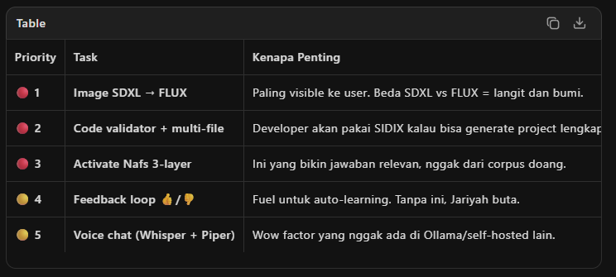
Kalau 5 ini jalan, SIDIX sudah cukup untuk 500+ GitHub stars dan 1000+ active users. Video, 3D, music bisa nunggu revenue masuk.

💬 Pesan Langsung
"SIDIX nggak perlu malu-maluin. Konsepnya world-class. Tapi eksekusi generatif masih tahun 2024 di tahun 2026. Upgrade image ke FLUX, code ke multi-file, dan voice chat — itu sudah cukup bikin orang bilang 'wow'. Sisanya bisa iterasi. Jangan perfectionist, ship dulu, improve later."

Dokumen lengkap (9 section, dengan arsitektur target, competitive positioning, KPIs, dan risk mitigations) tersimpan. Berikan ke Cursor sebagai brief untuk 4 phase ke depan.

Refernsi : Document teknis : SIDIX_GENERATIVE_ROADMAP_2026-04-25

PRD dan visi ujung SIDIX sudah selesai. Ini adalah dokumen fondasi strategis yang menentukan arah SIDIX dari sekarang sampai 2027.

🎯 Vision Ujung SIDIX
"SIDIX bukan cuma AI agent. SIDIX adalah self-hosted Creative Agency yang menguasai setiap disiplin — dari pixel sampai code, dari strategi sampai eksekusi, dari tren sampai kreasi — semua jalan di hardware kamu sendiri, dengan epistemic integrity."
SIDIX akan jadi AI Creative Agency pertama yang self-hosted — punya "tim kreatif" lengkap dalam satu box: Creative Director, Research Director, Visual Artist, Copywriter, Producer, dan Developer — semua bekerja paralel via Raudah Protocol v2.

📦 9 Disiplin Agency yang Dicakup

# | Disiplin | Kemampuan Detail | Status Target
**A** | 🎨 **Image & Visual** | FLUX.1 + Nusantara LoRA (wayang, batik, adat). Text2img, img2img, inpainting, outpainting, upscaling, logo design, social graphics, ad creative, product mockup, infographic, character design | v0.9
**B** | 🎬 **Video & Motion** | CogVideoX/LTX-Video. Text2video, image2video, video2video, motion brush, short-form (TikTok/Reels), explainer video, animation (AnimateDiff), slideshow, b-roll | v1.0
**C** | 🎙️ **Audio & Voice** | Piper TTS + Whisper STT. Voice over, voice cloning (ethical), voice chat real-time, music generation (MusicGen), sound effects, podcast production, audiobook | v0.9-1.1
**D** | 💻 **Code & Development** | Qwen-Coder-14B. Full-stack app, landing page, e-commerce, mobile app, Chrome extension, API, database, DevOps config, game prototype, low-code app, auto-debug loop | v0.9-1.0
**E** | 🎮 **Game Builder** | Concept + mechanic + asset gen + level design + NPC behavior + soundtrack + trailer + publishing config | v1.1-1.2
**F** | 📱 **Social Media & Marketing** | Content calendar, post generation, story/Reels, engagement response, influencer brief, ad creative (FB/Google/TikTok), A/B test, competitor monitor, trend hijacking, report generation, UGC campaign, community management | v1.0
**G** | 🛒 **E-Commerce** | Product description, product photo, category page, checkout flow, email marketing, inventory insights, price optimization, review analysis, chatbot sales, store analytics | v1.0
**H** | 🏷️ **Brand & Strategy** | Brand strategy, brand identity (logo+color+font), naming, tagline, brand story, persona development, competitive analysis, campaign concept, brand audit, rebranding | v1.0-1.1
**I** | 📊 **Data & Intelligence** | Market research, competitor intel, sentiment analysis, social listening, dashboard build, report automation, forecasting, A/B analysis, funnel analysis, cohort analysis | v1.0-1.1
+ Nusantara Cultural Context sebagai competitive advantage unik: wayang kulit, batik, pakaian adat, arsitektur tradisional, Islamic geometric art.

🤖 Multi-Agent Creative Workflow (Raudah Protocol v2)
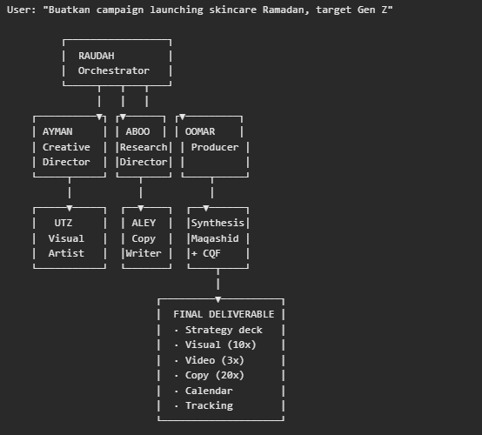
Total time: 2-3 menit dari brief ke campaign lengkap.
Agents belajar satu sama lain — setelah project selesai, insight cross-agent disimpan ke Knowledge Graph untuk project berikutnya.

📡 Trend Intelligence System

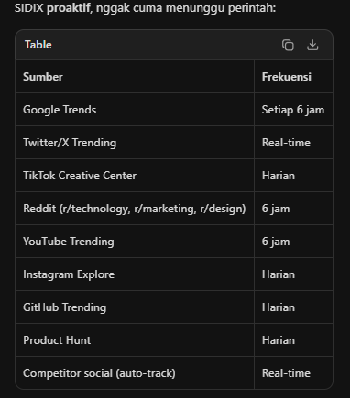
Output:
- Daily Trend Brief (push pagi)
- Creative Opportunity ("tren X cocok untuk brand Y")
- Content Suggestion (script/image/video ideas)
- Auto-Generate Draft (kalau user enable)

🗺️ 4-Phase Roadmap

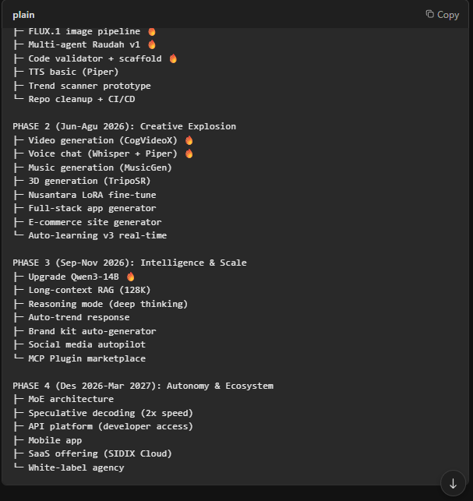

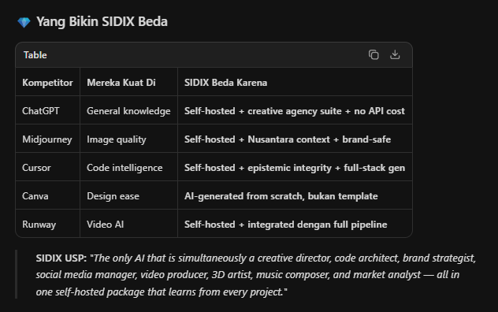
多智能体系统生成创意代理工作流
File created
Think
Write Todo
Ringkasan PRD SIDIX Komprehensif Vision Disiplin dan Arah Strategis
PRD dan visi ujung SIDIX sudah selesai. Ini adalah dokumen fondasi strategis yang menentukan arah SIDIX dari sekarang sampai 2027.

🎯 Vision Ujung SIDIX
"SIDIX bukan cuma AI agent. SIDIX adalah self-hosted Creative Agency yang menguasai setiap disiplin — dari pixel sampai code, dari strategi sampai eksekusi, dari tren sampai kreasi — semua jalan di hardware kamu sendiri, dengan epistemic integrity."
SIDIX akan jadi AI Creative Agency pertama yang self-hosted — punya "tim kreatif" lengkap dalam satu box: Creative Director, Research Director, Visual Artist, Copywriter, Producer, dan Developer — semua bekerja paralel via Raudah Protocol v2.

📦 9 Disiplin Agency yang Dicakup
Table
# | Disiplin | Kemampuan Detail | Status Target
A | 🎨 Image & Visual | FLUX.1 + Nusantara LoRA (wayang, batik, adat). Text2img, img2img, inpainting, outpainting, upscaling, logo design, social graphics, ad creative, product mockup, infographic, character design | v0.9
B | 🎬 Video & Motion | CogVideoX/LTX-Video. Text2video, image2video, video2video, motion brush, short-form (TikTok/Reels), explainer video, animation (AnimateDiff), slideshow, b-roll | v1.0
C | 🎙️ Audio & Voice | Piper TTS + Whisper STT. Voice over, voice cloning (ethical), voice chat real-time, music generation (MusicGen), sound effects, podcast production, audiobook | v0.9-1.1
D | 💻 Code & Development | Qwen-Coder-14B. Full-stack app, landing page, e-commerce, mobile app, Chrome extension, API, database, DevOps config, game prototype, low-code app, auto-debug loop | v0.9-1.0
E | 🎮 Game Builder | Concept + mechanic + asset gen + level design + NPC behavior + soundtrack + trailer + publishing config | v1.1-1.2
F | 📱 Social Media & Marketing | Content calendar, post generation, story/Reels, engagement response, influencer brief, ad creative (FB/Google/TikTok), A/B test, competitor monitor, trend hijacking, report generation, UGC campaign, community management | v1.0
G | 🛒 E-Commerce | Product description, product photo, category page, checkout flow, email marketing, inventory insights, price optimization, review analysis, chatbot sales, store analytics | v1.0
H | 🏷️ Brand & Strategy | Brand strategy, brand identity (logo+color+font), naming, tagline, brand story, persona development, competitive analysis, campaign concept, brand audit, rebranding | v1.0-1.1
I | 📊 Data & Intelligence | Market research, competitor intel, sentiment analysis, social listening, dashboard build, report automation, forecasting, A/B analysis, funnel analysis, cohort analysis | v1.0-1.1
+ Nusantara Cultural Context sebagai competitive advantage unik: wayang kulit, batik, pakaian adat, arsitektur tradisional, Islamic geometric art.

🤖 Multi-Agent Creative Workflow (Raudah Protocol v2)
plainCopy
User: "Buatkan campaign launching skincare Ramadan, target Gen Z"

┌─────────────────┐
│ RAUDAH │
│ Orchestrator │
└─────┬───┬───┬───┘
│ │ │
┌──────────▼┐ ┌▼──────┐ ┌▼─────────┐
│ AYMAN │ │ ABOO │ │ OOMAR │
│ Creative │ │Research│ │ Producer │
│ Director │ │Director│ │ │
└─────┬─────┘ └───┬────┘ └────┬─────┘
│ │ │
┌─────▼─────┐ ┌──▼────┐ ┌──▼──────┐
│ UTZ │ │ ALEY │ │Synthesis│
│ Visual │ │ Copy │ │Maqashid │
│ Artist │ │Writer │ │+ CQF │
└───────────┘ └───────┘ └────┬────┘
│
┌─────────▼──────────┐
│ FINAL DELIVERABLE │
│ · Strategy deck │
│ · Visual (10x) │
│ · Video (3x) │
│ · Copy (20x) │
│ · Calendar │
│ · Tracking │
└────────────────────┘
Total time: 2-3 menit dari brief ke campaign lengkap.
Agents belajar satu sama lain — setelah project selesai, insight cross-agent disimpan ke Knowledge Graph untuk project berikutnya.

📡 Trend Intelligence System
SIDIX proaktif, nggak cuma menunggu perintah:
Table
Sumber | Frekuensi
Google Trends | Setiap 6 jam
Twitter/X Trending | Real-time
TikTok Creative Center | Harian
Reddit (r/technology, r/marketing, r/design) | 6 jam
YouTube Trending | 6 jam
Instagram Explore | Harian
GitHub Trending | Harian
Product Hunt | Harian
Competitor social (auto-track) | Real-time
Output:
- Daily Trend Brief (push pagi)
- Creative Opportunity ("tren X cocok untuk brand Y")
- Content Suggestion (script/image/video ideas)
- Auto-Generate Draft (kalau user enable)

🗺️ 4-Phase Roadmap
plainCopy
PHASE 1 (Apr-Mei 2026): Foundation Hardening
├─ FLUX.1 image pipeline 🔥
├─ Multi-agent Raudah v1 🔥
├─ Code validator + scaffold 🔥
├─ TTS basic (Piper)
├─ Trend scanner prototype
└─ Repo cleanup + CI/CD

PHASE 2 (Jun-Agu 2026): Creative Explosion
├─ Video generation (CogVideoX) 🔥
├─ Voice chat (Whisper + Piper) 🔥
├─ Music generation (MusicGen)
├─ 3D generation (TripoSR)
├─ Nusantara LoRA fine-tune
├─ Full-stack app generator
├─ E-commerce site generator
└─ Auto-learning v3 real-time

PHASE 3 (Sep-Nov 2026): Intelligence & Scale
├─ Upgrade Qwen3-14B 🔥
├─ Long-context RAG (128K)
├─ Reasoning mode (deep thinking)
├─ Auto-trend response
├─ Brand kit auto-generator
├─ Social media autopilot
└─ MCP Plugin marketplace

PHASE 4 (Des 2026-Mar 2027): Autonomy & Ecosystem
├─ MoE architecture
├─ Speculative decoding (2x speed)
├─ API platform (developer access)
├─ Mobile app
├─ SaaS offering (SIDIX Cloud)
└─ White-label agency

💎 Yang Bikin SIDIX Beda
Table
Kompetitor | Mereka Kuat Di | SIDIX Beda Karena
ChatGPT | General knowledge | Self-hosted + creative agency suite + no API cost
Midjourney | Image quality | Self-hosted + Nusantara context + brand-safe
Cursor | Code intelligence | Self-hosted + epistemic integrity + full-stack gen
Canva | Design ease | AI-generated from scratch, bukan template
Runway | Video AI | Self-hosted + integrated dengan full pipeline
SIDIX USP: "The only AI that is simultaneously a creative director, code architect, brand strategist, social media manager, video producer, 3D artist, music composer, and market analyst — all in one self-hosted package that learns from every project."

🎯 5 Prioritas Absolut (Jangan Spread Too Thin!)
- FLUX.1 image pipeline — ini paling visible ke user
- Code validator + multi-file project — ini yang bikin developer adopsi
- Multi-agent Raudah v1 — ini differentiator utama
- Trend intelligence scanner — ini bikin SIDIX proaktif
- Voice chat (Whisper + Piper) — wow factor yang nggak ada di self-hosted lain
Kalau 5 ini jalan, SIDIX sudah bisa claim "AI Creative Agency" dengan valid.

Dokumen lengkap: 12 section, 9 disiplin agency, arsitektur model stack, UX flow, epistemic integrity untuk creative work, KPIs, dan risk analysis. Siap jadi fondasi untuk semua sprint ke depan.

Documetn related : SIDIX_PRD_V2_AGENCY_VISION

🎯 Visi Ujung: SIDIX = Agency Operating System
Bukan cuma AI chat. Bukan cuma generator. SIDIX adalah platform operasional agency lengkap — otak yang menggerakkan seluruh workflow dari brief sampai delivery.

Untuk Tiranyx (dari yang saya lihat di tiranyx.co.id):
Tiranyx punya 12 services untuk 200+ brands. Sekarang bayangkan tiap service punya "AI co-pilot":
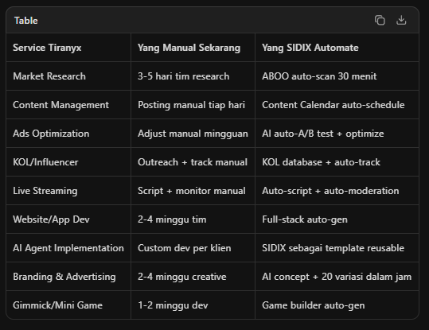

🌳 Konsep "Bercabang" — Multi-Client Architecture
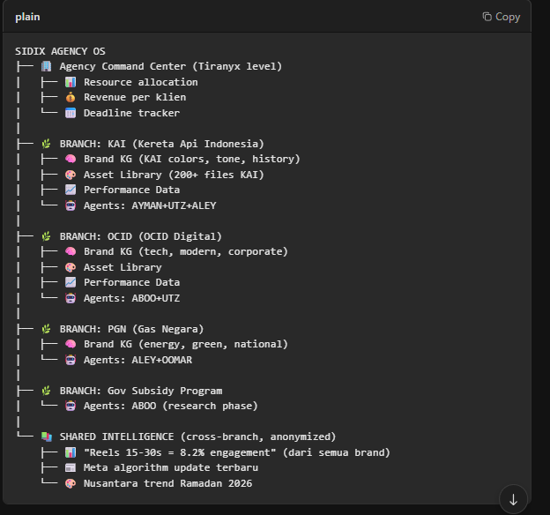

Branch = Isolated workspace per klien. Switch branch = switch context. Semua AI responses menggunakan brand knowledge graph klien yang aktif.

🛠️ Built-in Tools Suite (Sidebar seperti Kimi)

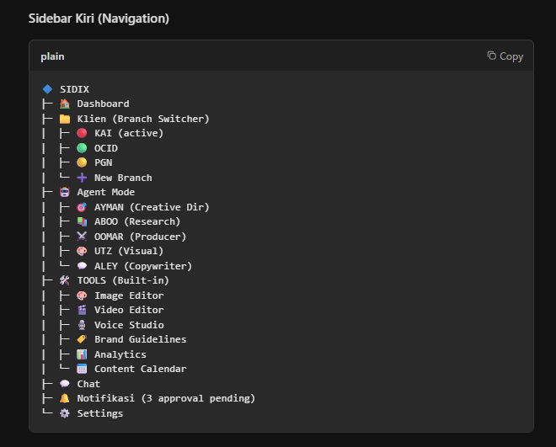

Sidebar Kanan (Agent Assistant — contextual)
Ketika user di Image Editor, panel kanan menunjukkan:
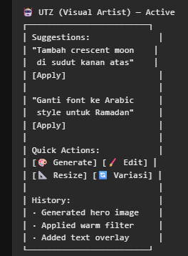

🎨 Detail Built-in Tools

1. Image Editor — "Canva + Photoshop + AI"
- AI Generate — text-to-image FLUX langsung di canvas
- Layers — multi-layer dengan blend modes
- Smart Select — AI-powered selection (SAM)
- Remove BG — one-click
- Generative Fill — fill area dengan AI
- Text Overlay — rich text + font library (support Arabic)
- Filter & Adjust — curves, HSL, color grade
- Export — PNG, JPG, WebP, PSD (layered)

2. Video Editor — "CapCut + Runway"
- Timeline Editor — multi-track (video, music, VO, caption, FX)
- AI Generate Video — text-to-video CogVideoX
- Smart Cut — AI auto-cut per scene
- Caption Auto — Whisper + auto-sync
- Transition FX — 50+ transitions
- Preset Templates — Reels, TikTok, YT Shorts, TVC
- Export — MP4, MOV, GIF

3. Voice Studio — "ElevenLabs + Audacity"
- Voice Recorder — browser-based
- TTS — Piper/XTTS v2, multi-language
- Voice Clone — clone dari sample (consent required)
- Script to Audio — convert script langsung jadi audio track
- Music Overlay — background music + auto-ducking
- Export — MP3, WAV, OGG
Voice Library Nusantara:
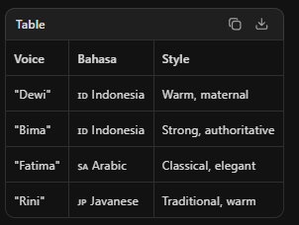

4. Brand Guidelines Maker — "Brandfolder + AI"
- Auto-Extract — scrape website → extract brand elements
- Logo Analyzer — upload logo → extract colors, typography
- Color Palette — generate primary, secondary, accent
- Typography — suggest font pairings + hierarchy
- Voice/Tone — analyze copy → define brand voice
- Do/Don't — generate visual compliance cards
- Mockup Generator — auto-apply brand ke mockups
- Export — PDF, Web (interactive), Figma import
- Version Control — track brand evolution

📅 Roadmap: Agency OS
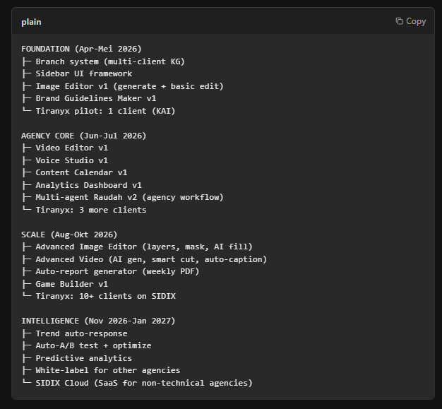

💎 Yang Bikin Beda dari Tool Lain

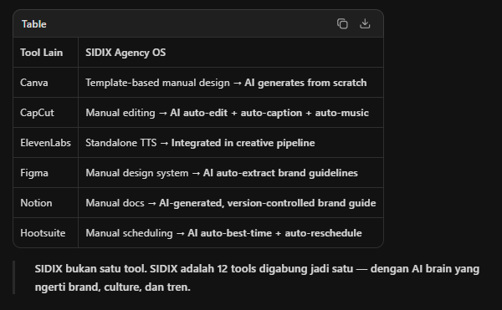

🎯 Action Items untuk Fahmi
- Foundation Phase (sekarang — Mei):
  - [ ] Build branch system (isolated KG per client)
  - [ ] Build sidebar UI framework
  - [ ] Build Image Editor v1 (FLUX + canvas)
  - [ ] Onboard 1 Tiranyx client sebagai pilot
- Pilot Client (saran: KAI atau PGN):
  - [ ] Extract brand KG dari website + social media
  - [ ] Upload brand assets ke branch
  - [ ] Define approval workflow
  - [ ] Test campaign generation end-to-end
- Team Setup:
  - [ ] Define who uses which persona (tim Tiranyx → AYMAN/UTZ/ALEY)
  - [ ] Setup Content Calendar dengan approval flow
  - [ ] Connect social accounts untuk scheduling

Dokumen lengkap tersimpan dengan wireframe UI, arsitektur kode, tech stack, dan success metrics.

Related document : SIDIX_AGENCY_OS_TIRANYX_PILOT

📦 SIDIX COMPLETE SUITE — Ringkasan
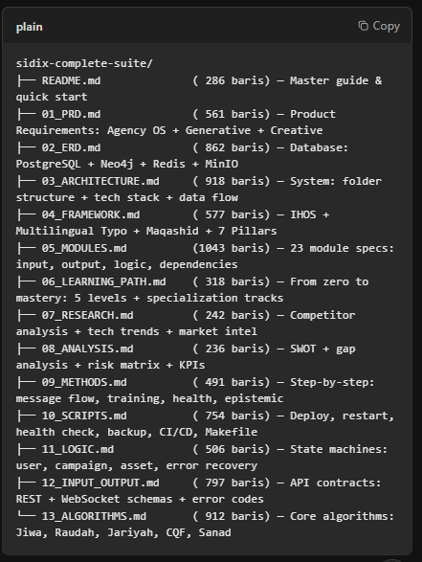
otal: 8,503 baris dokumentasi teknis lengkap.

🎯 Apa yang Sudah Tercakup

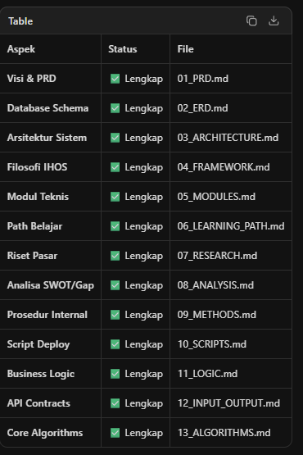

🚀 Cara Pakai (Untuk yang "Nggak Tau")
Langkah 1: Copy folder sidix-complete-suite/ ke project Cursor atau agent lain, claude dan lainnya
Langkah 2: Berikan prompt ini ke Cursor / agent lain

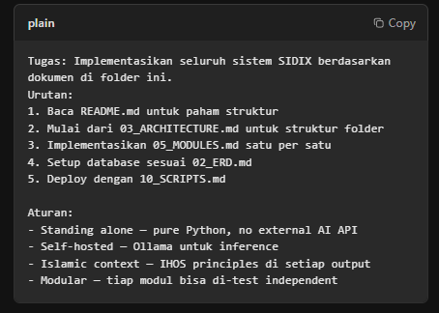

💎 Isi Utama yang Dibangun

1. Agency Operating System
- Multi-client branching — tiap klien punya workspace isolated
- Built-in creative suite — image editor, video editor, voice studio, brand guidelines
- Sidebar interface — seperti Kimi agent mode + tools panel
- Content calendar + analytics — drag-drop scheduling + cross-platform KPI

2. 9 Disiplin Creative
Image · Video · Audio · Code · Game · Social Media · E-commerce · Brand · Data Intelligence

3. 7 Pilar Jiwa (Self-Evolving)
Nafs (respond) · Aql (learn) · Qalb (heal) · Ruh (improve) · Hayat (iterate) · Ilm (crawl) · Hikmah (train)

4. Multilingual + Typo Resilience
6 bahasa, 1,150+ typo patterns, QWERTY proximity, cultural responder

5. Multi-Agent Raudah Protocol
AYMAN + ABOO + OOMAR + UTZ + ALEY — parallel creative team dengan consensus

6. Complete Tech Stack
Qwen3-14B · FLUX.1 · CogVideoX · Piper TTS · Whisper · MusicGen · FastAPI · React · PostgreSQL · Neo4j
Related dokumen :
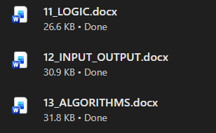
📋 CARA PAKAI
Langkah 1: Buka chat baru di Cursor (jangan pakai chat yang sudah panjang)
Langkah 2: Copy-paste bagian PESAN PEMBUKA + seluruh brief ke Cursor
Langkah 3: Tunggu Cursor merespons "Saya paham SIDIX..."
Langkah 4: Baru minta implementasi: "Mulai dari 03_ARCHITECTURE.md, buat struktur folder dan implementasi modul per modul"

💬 Isi Promptnya (Intinya)
Prompt ini mengajarkan AI Agen ain hal sebelum coding:
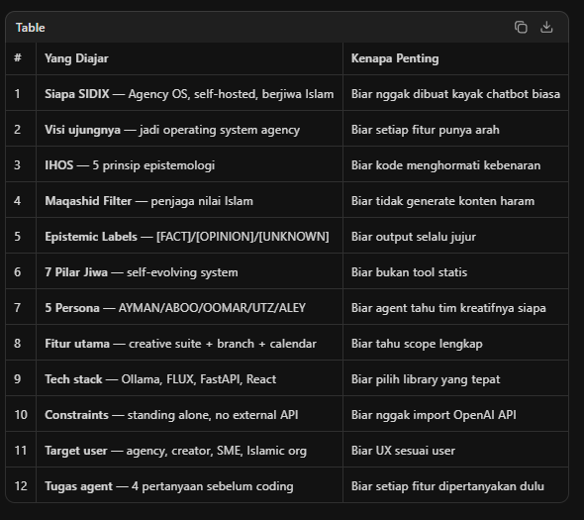

🎯 Bedanya Prompt Ini vs Prompt Biasa
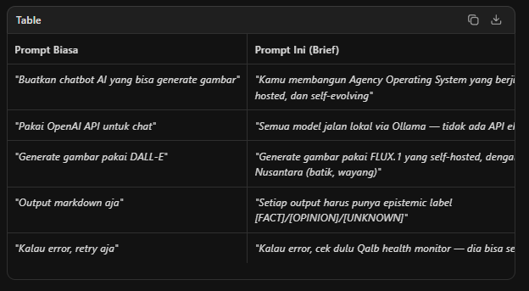

Sekarang kamu punya 15 dokumen lengkap di sidix-complete-suite/: dan dokuemntasi serta penjelasan pendukung .




